Answer Sheet – COSC2506 Practical Test 2 (30% - 20 Points)

Task 1 – Commands – Archive & Security (Q1-Q7 – 7x1 = 7 points)
Copy your answers/outputs from the terminal here.
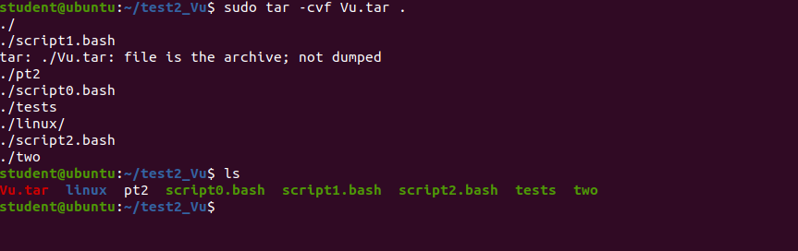

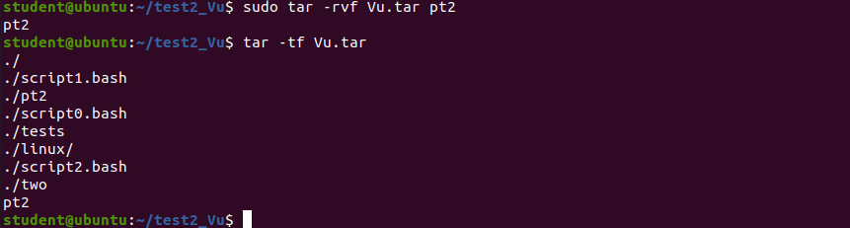

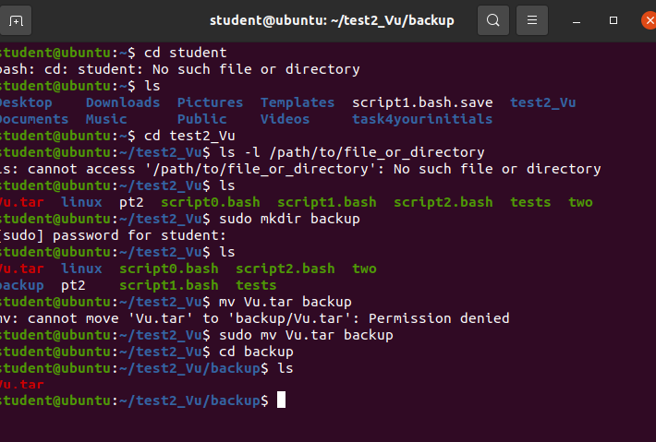

Task 2 – Fix Errors (2 points)
Write your answers in the space provided.
#!/bin/bash
COUNT=0
RESULT=0
while [ $COUNT -le 100 ]
do
RESULT=`expr $RESULT + $COUNT`
COUNT=`expr $COUNT + 1`
done
echo "Result is $RESULT"

Error 1/Change 1:

Error 2/Change 2:

Task 3 – Scripts (5 + 6 = 11 points)
Copy your scripts codes/outputs from the terminal here.

----------------------------------------------------------------------------------------

Script1 (script1.bash) Code
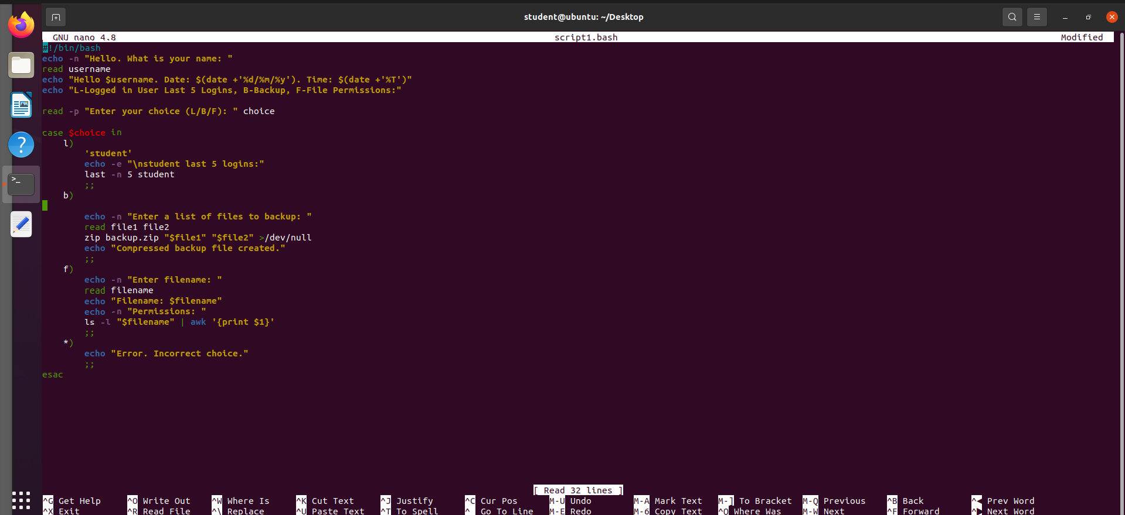

Script1 (script1.bash) Output
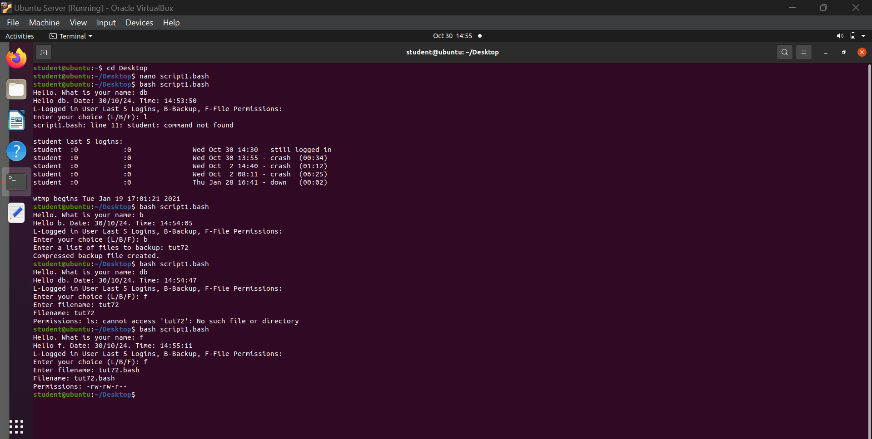

----------------------------------------------------------------------------------------

Script2 (script2.bash) Code

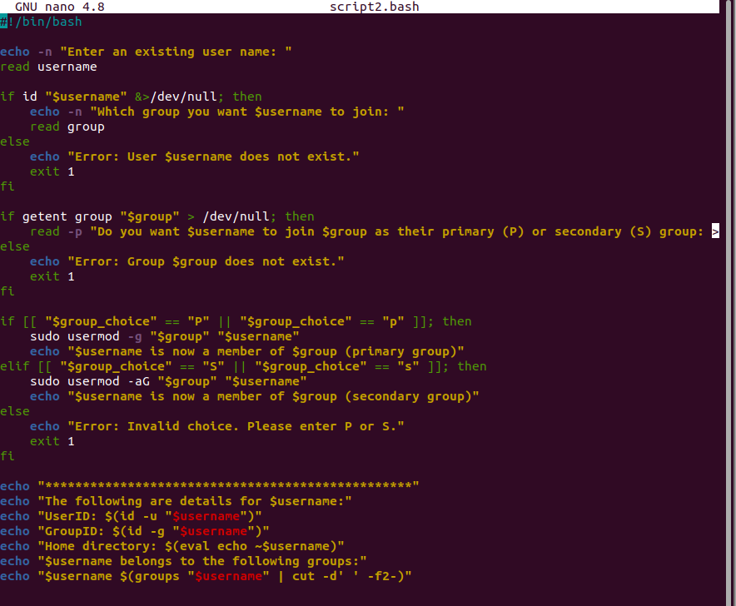

Script2 (script2.bash) Output
